STEP 1:

USER --> Chrome
|
One tab -> URL --> amazon.com

|
Computer
Mobile
| |
Client --------------------------------------> Server

STEP 2:

USER --> Server --> DB
Computer amazon.com Productid | product name | price
1 book 200

USER : URL : www.amazon.com\mobilephone\b\search?=all --> Server

| | |

Client String URL mapped => REST API == > DB

Client browser < ==== API < === Mobile phone data
|||

Can view all mobile phones
{ UI : HTML }

Challenge’s :

- Product data { view }
- Customer Buy : after viewing product data
- Customer trans-cation history

STEP 3:

Legacy Storage :{ harddisk }

- Data can stored in many ways
- File’s
| | |
Text word excel

  - File operation
  - Create file
  - Naming the file
  - Enter some data in to file
  - Close the file
  - Again open file
  - Read the data in the file

- Application’s 3. Library using coding

Excel Excel
| |
Ms office Library function’s

STEP 4:

Web technology Storage :

Data is stored in one way’s
Database
|
Table { flle }
|
Productid | product name | price
1 book 200

Challenge’s :

- What u have purchased that data we can see 10 record’s
- All data related to product u can see
- Data entry happens to table when u signup , buy & authentication done by user name | mobile name | email id
- Data history with username | email id

STEP 5:

Computer
||
Software : windows os & hardware configuration
||
Hard disk
||
Os software information ==> owned by os File Windows 7
Hardware information ==> owned by os File Core i3 , 4 GB
| |
Os software information ==> owned by os File Windows 10
Hardware information ==> owned by os File 8G B
| |
File :=> Update

HARDDISK
||
Software.txt ---> when user bought laptop software information & hardware information
||
Software.txt --> User again updates the software the file content is overwritten

HARDDISK
||
Software.txt => when user updates this file => Record1 which creates new file => user1.txt
1 user
Time & date
Key & productid
HARDDISK
||
Software.txt => when user updates this file => Record12 which creates new file =>user2.txt
2 user
Time & date
Key & productid

Record is created => Each time when file gets update & store one record

user1.txt user2.txt

| |
Data Data
| |
Block 1 Block2

RECORD 1 ===> RECORD 2

Windows 7 Windows 10
4 GB 8 GB

user1.json user2.json

| |
Data Data
| |
Block 1 Block2

Block chain

Data is stored as record
Record distributed record-keeping system called a ledger
|
Productid | product name | price
1 book 200

Contract
| |
mapping Block
DS { file system }

DS <= copied Msg.sender
Msg.value

- Block chain record data is copied to DS
- Block chain Filsystem data is transformed in to mapping data structure
- Public blockchain

Block chain Overview

USER ==> REST API => SERVER1 ==> SEVER 2

DB Table ledger

Contract details
Trancation details Buy | record 1 File immutable
Sell | record 2
Owneship | record 2

Able to securely record, store and share data,

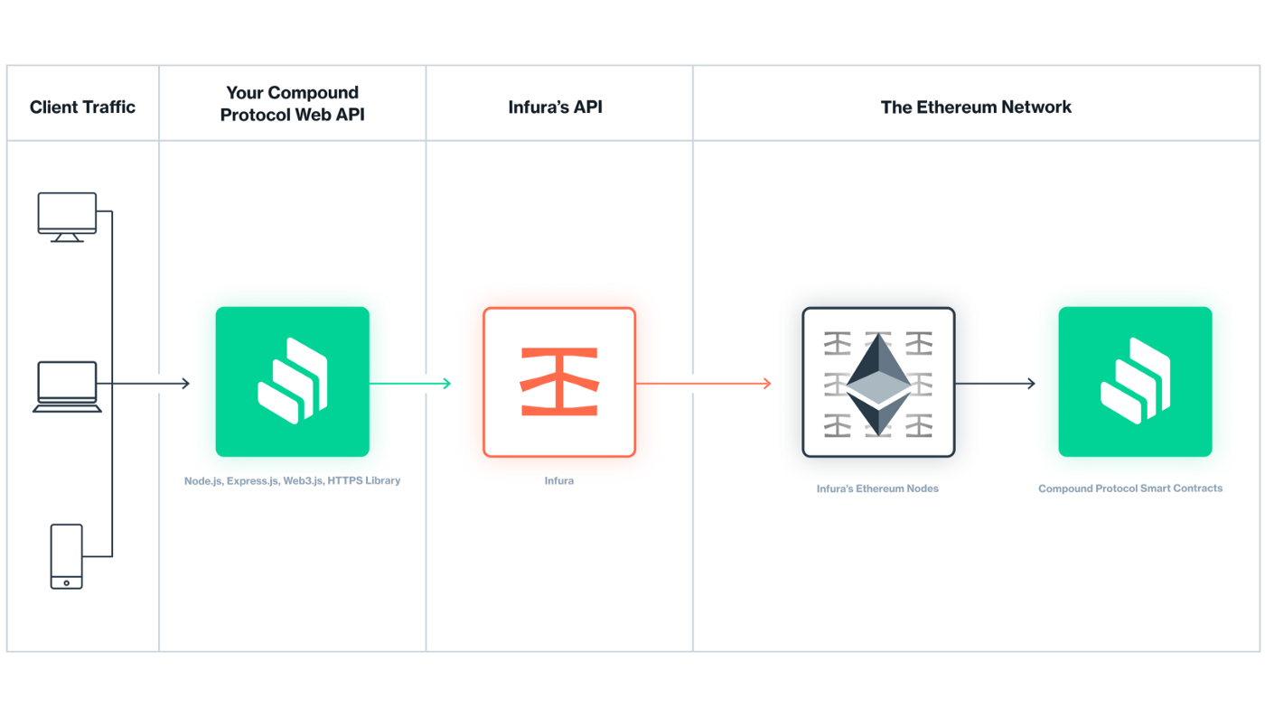

Concept’s to be learned :
- Constructor copy sender data in to contract variable’s
- Methods with payable

Coding PRinciple’s

1.MApping data structure <== sender of the current message {Contract }

2.Blockchain FileSystem <==> event

https://medium.com/mycrypto/understanding-event-logs-on-the-ethereum-blockchain-f4ae7ba50378

https://medium.com/@jgm.orinoco/why-use-the-withdrawal-pattern-d5255921ca2a

- Multiple Mapping data structure <== ERC20 contract , Event’s {transfer , approve }

https://ethereum.org/en/developers/tutorials/understand-the-erc-20-token-smart-contract/

https://www.toptal.com/ethereum/create-erc20-token-tutorial

https://www.jdsupra.com/legalnews/an-overview-of-blockchain-in-supply-3023363/

- Authentication

https://medium.com/coinmonks/how-to-do-authentication-in-decentralized-application-dapp-d9bc66b6249c

- Authorization & secuirty

https://consensys.net/blog/developers/solidity-best-practices-for-smart-contract-security/

- Middleware

https://betterprogramming.pub/making-http-requests-in-solidity-b472c2b5e5f1

- Testing

https://medium.com/robhitchens/solidity-crud-part-1-824ffa69509a

https://www.businesstoday.in/opinion/columns/story/blockchain-technology-record-store-share-data-106602-2018-05-22

